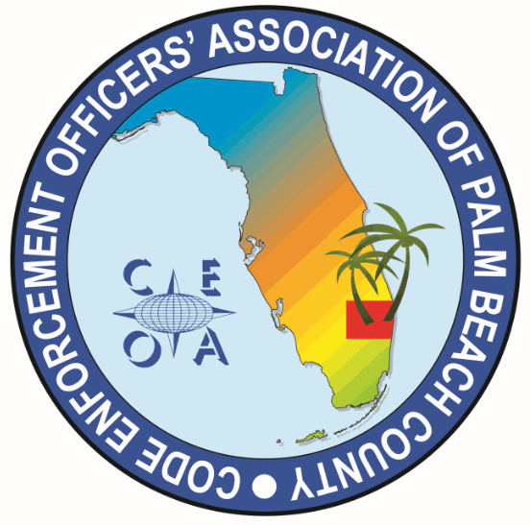
CODE ENFORCEMENT OFFICERS ASSOCIATION OF PALM BEACH COUNTY
BOARD MEETING AGNDA
MARCH 20, 2025
1:00 PM
TOWN OF HAVERHILL
4585 CHARLOTTE STEET, HAVERHILL, FL 33417

CALL MEETING TO ORDER, ROLL CALL, ESTABLISH A QOURUM
APPROVAL OF MEETING MINUTES FROM FEBRUARY 12, 2025

TREASURER REPORT AND PROPOSED 2025 -2026 BUDGET – Joe Oliva

OLD BUSINESS

- MARCH 27TH ANNUAL MEETING AND TRAINING (74 RSVP so far expecting a large turnout)
- Raffle tickets for Beats head phones to be passed out prior to 11:00 AM
- 50/50 raffle anytime prior to training introduction
- Lunch set up all board members needed. Joe O. and Sonja arrange for pizza and salad, drinks, plates, napkins and forks. Lunch at 11:00 AM
- 12:00 PM Annual meeting. Presentation of chapter accomplishments and annual budget.
- Election procedures. Review vacancies. Quorum needed for election
- 1:00 PM to 3:00 PM Training block. Annual meeting and elections must be completed by 1:00 PM

- F.A.C.E. CONFRENCE SPONSORSHIP, DONATIONS, TABLE RAFFLE DISCUSSION
- CONSIDERATION OF ENDORSING/SUPPORTING MICHAEL SAVAGE, BUILDING OFFICIAL/DIRECTOR MARION COUNTY, FLORIDA FOR SECRETARY/TREASURER ICC BOARD OF DIRECTORS

NEW BUSINESS

- FUTURE TRAIINING SPEAKERS TOPICS AND LOCATIONS
- ITEMS TO BE CONSIDERED AT OUR NEXT BOARD MEETING
- SET MEETING DATE

ADJOURNMENT

.

